**Rent-A-Car Management System**

**Problem Statement:**

The case study titled Rent-A-Car Management System is a Rental Management Software for the purpose of monitoring and controlling hire a car. This case study on the Rent-A-Car management system gives us the complete information about the provider/supplier of rent car and the daily hire car from the provider(S). We need to maintain the record of new customer and search the details of the car available from the provider which mainly focuses on basic operation in a rental like adding new customer, Rent car, and update information searching car and member and facility to hire and returns car. Its features common familiar and well-thought-out, an attractive user interface, combined with strong searching, insertion and reporting capabilities. The report generation facility of rental systems helps to get a good idea of which are the hire by the customer, makes users possible to generate hard copy.

The following are the brief description on the functions achieved through this case study:

**End-Users:**

* Provider: To maintain and update the history and also create the need of the customer/user.
* Customer: Need a car and also places various requests to the Provider.
* Shareholder: Required a car providing this required and also take any kinds of request to The Provider.

**Class Diagram:**

Classes identified:

* Booking
* Provider
* Cars
* Customer(hirer)
* Shareholder

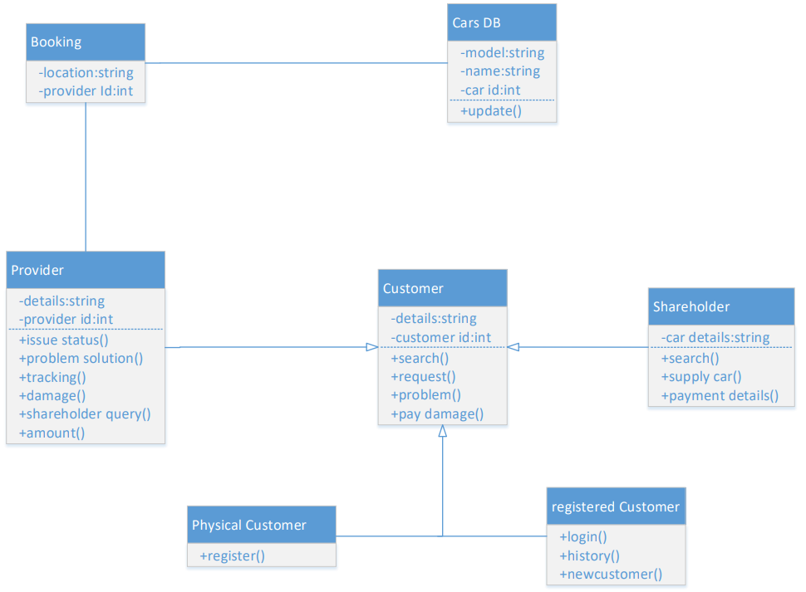

**Use-Case Diagram:**

Actors vs. Use Cases:

Provider

* Issue Status
* Update And Manage Records
* Request The Provider For A Car
* Track Problems

Customer

* Register
* Login
* Search A Car
* Review
* Booking
* Request To Provider
* New Customer

Cars DB

* Update Car
* Show Car Availability

Shareholder

* Provider A Car To The Provider
* Payment Acknowledgement

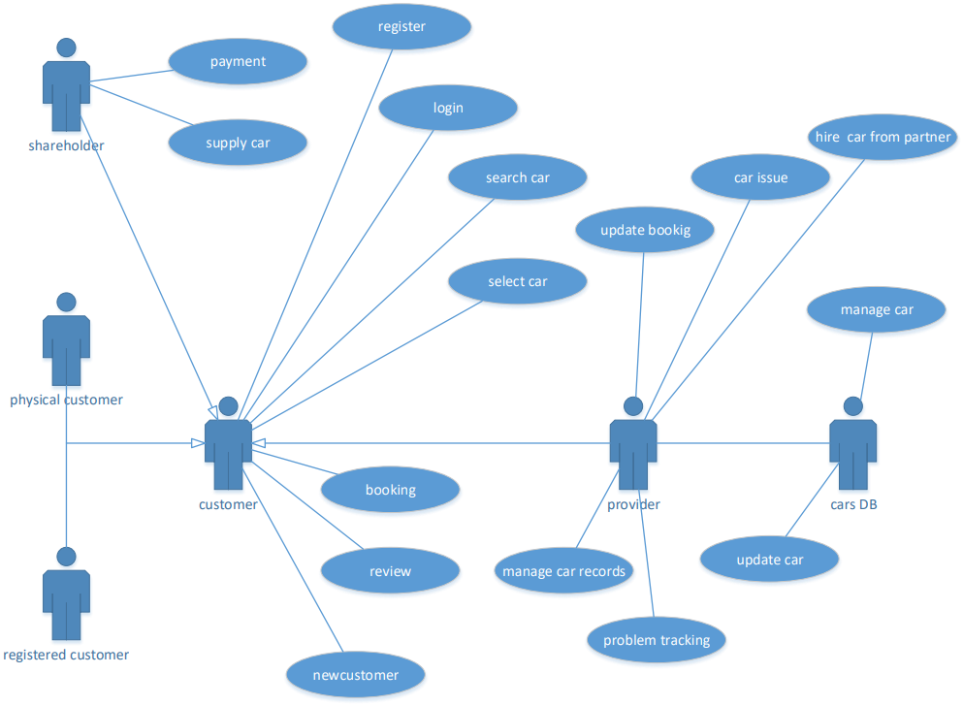

**Sequence Diagram:**

* Sequence Diagram for searching a Car and issuing it as per the request by the Customer from the Provider:

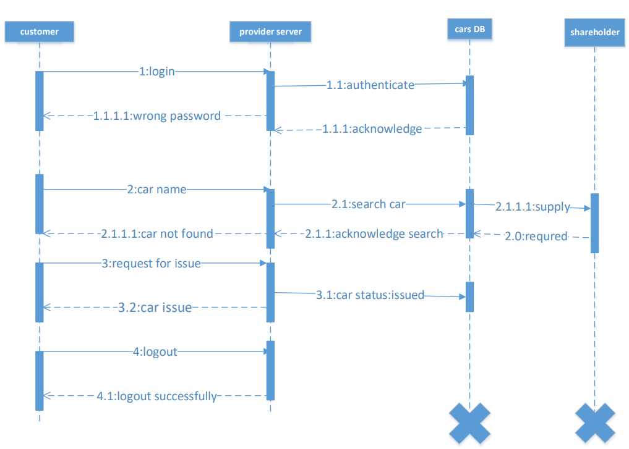

**Activity Diagram:**

* Customer login and Authentication
* Search car operation for Rent
* Acknowledge and issue cars to the customers by the provider
* Provide Cars requested by the Provider from the shareholder
* Bill pay from the provider to the shareholder
* Cars condition of the Cars update in the Cars DB

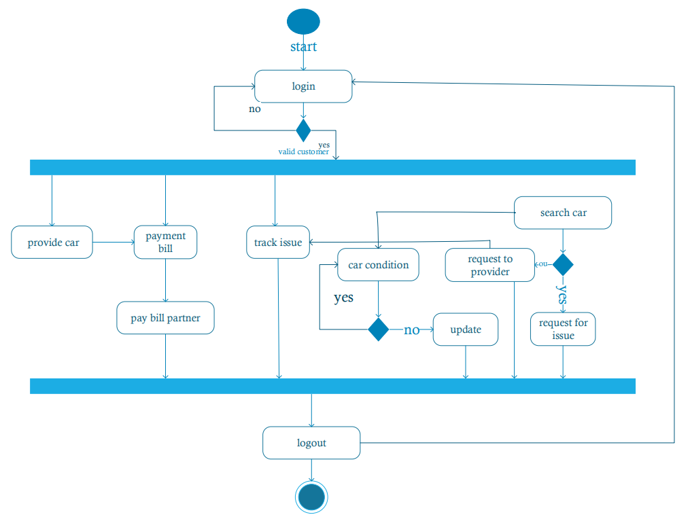

**State Chart Diagram:**

States:

* Authentication
* Successfully logged on or login
* Search for car (customer)/request to the provider
* Receive acknowledgement
* Logged off/re-search

Transition:

* Authenticate-🡪logged in
* Logged in🡪 Search🡨-🡪acknowledgement
* Logged in🡪 request shareholder🡨-🡪 provide car🡨-🡪acknowledgement
* Logged in🡪 provide car🡨-🡪acknowledgement
* Authenticate-🡪logged 0ff

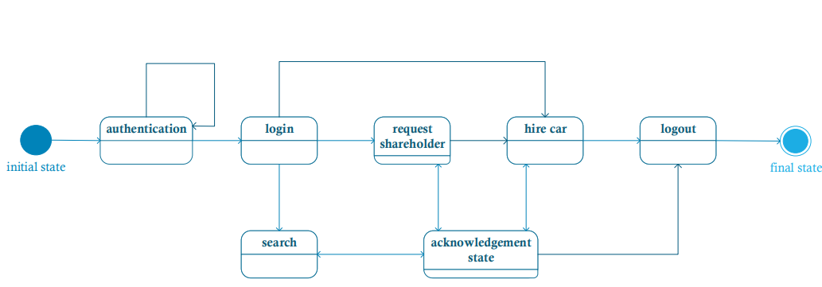

**CRC-Card Diagram:**

